**Raise your sights, excite your customers**

Don’t be afraid of customer complaints.

**Is**customer satisfaction enough, or is customer success with your product or service important?

[Dan Gingiss](https://twitter.com/dgingiss) bristled at the question.

“Can someone please explain the difference?” he said. “Why would customers be satisfied if they are not successful with the product or service?”

Gingiss is passionate about customer service, particularly through social media. An author, podcaster and speaker, he has written, “[Winning at Social Customer Care: How Top Brands Create Engaging Experiences on Social Media](https://www.amazon.com/Winning-Social-Customer-Care-Experiences/dp/1542732387).”

Twitter is one of the prime platforms for customer interaction. It’s where Gingiss and social media marketing entrepreneur [Madalyn Sklar](https://twitter.com/MadalynSklar) share a common fervor.

Tweets are instant engagement. They’re the next best thing to talking to a person on the phone or in person. Plus, the rest of the world judges and — you hope — appreciates your response.

“Twitter has become crucial to the customer experience,” Gingiss said. “Customers are more willing than ever to share their experiences publicly with friends and followers.

“A quick scan of a the ‘Tweets and Replies’ stream of any brand gives a prospect a pretty good idea of what it’s like to do business with that brand,” he said.

The business side also holds potential.

“Twitter is a terrific customer-listening tool for companies to better understand what they’re doing well, what needs to be improved and what their customers want, such as new products,” Gingiss said.

“How — or if — brands respond to customers on Twitter also contributes to the overall customer experience,” he said. “Speed of response matters a lot as well.”

In this way, Twitter has become vital to a brand’s customer service, according to Sklar.

“So many of us turn to Twitter to sing praise and complain,” she said. “It’s more important than ever to offer a great customer experience on Twitter.”

Successful brands grasp which of their experiences to share on Twitter.

“I have developed a very simple equation to determine the experiences that get shared,” Gingiss said. “Expectations + Emotions = Willingness to Share.

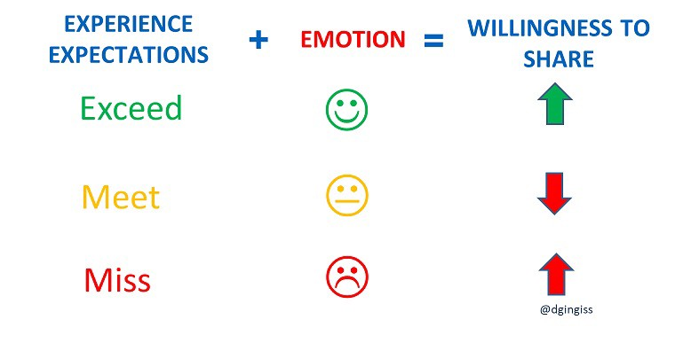

“When companies exceed expectations, they make customers happy,” he said. “Those customers are highly likely to share that positive customer experience. This is because, unfortunately, exceeding expectations is still rare. Brands have huge opportunities.”

Failing to put in the effort will show in the final results.

“When companies meet or barely meet expectations, there is no emotional response — or ‘Meh,’ as millennials might say,” Gingiss said. “So, there’s no incentive to share.

“When companies miss expectations, they make customers sad or angry,” he said. “Those customers are very likely to share that negative customer experience on social media. They are either looking for sympathy, want to embarrass the brand or want a resolution.”

Positive content exchanged on social media has common elements.

“What gets shared on Twitter and with customer experience is similar: A beautiful view, a funny sign, a friendly face, something unique and different, something literally remarkable — worthy of commenting on,” Gingiss said.

“The signs companies put up say a lot about what it’s like to do business with them,” he said. “Are they customer-friendly or not?”

People love to share what Gingiss calls “surprise and delight” moments.

“Although this is an overused term, when businesses surprise customers in a positive way, that moment is often worth sharing,” he said.



“Personalized experiences often get shared,” Gingiss said. “Perhaps the best example of this is [Coca Cola](https://twitter.com/CocaCola/)’s Share a Cole campaign, which makes it so natural for customers to share.”

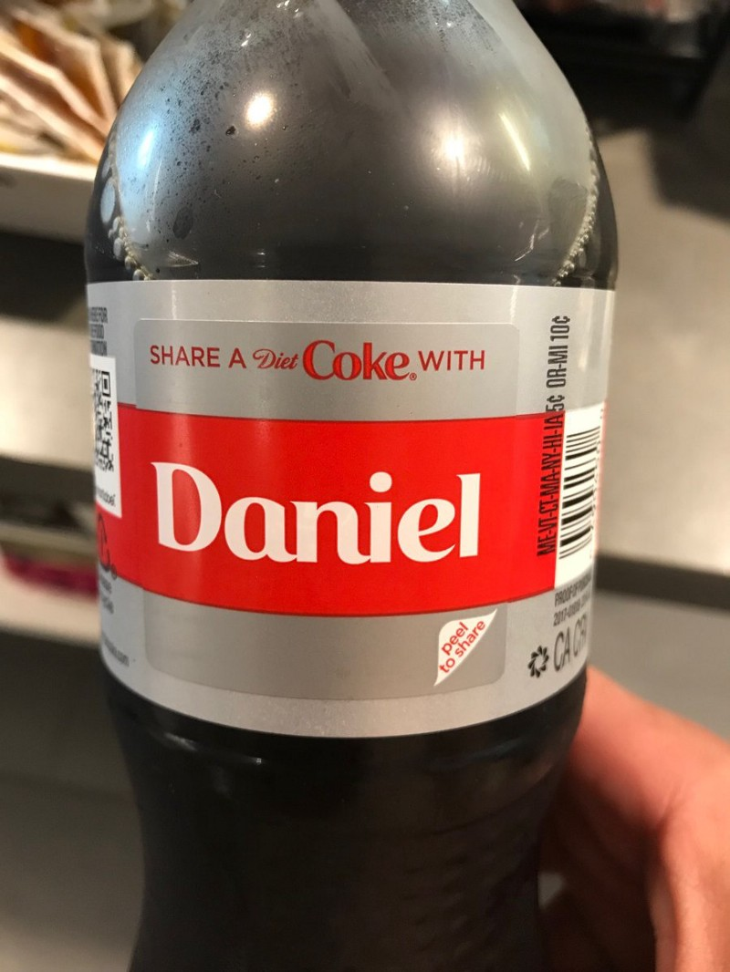

Say anything bad about customer experience, and critics will have a feeding frenzy.



A United Airlines passenger and, ultimately, the carrier had a bad day.

“Remember this guy?” Gingiss asked. “Companies must keep in mind that everyone has the ability to snap a photo or record a video of their customer experience — or someone else’s.

“The nerve of a Las Vegas hotel to charge $5 for in-room coffee, a $39 ‘resort fee’ and serve $34 cocktails caused me to write a whole article on [Forbes](https://twitter.com/Forbes/" \t "_blank)about my experience.”

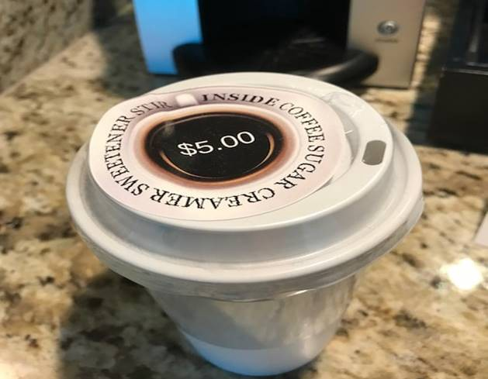

“Often customers use social media as a customer service channel of last resort, meaning that another channel — phone, email, chat — failed before the customer went ‘public,’” Gingiss said. “But increasingly, customers are turning to Twitter first because it’s fast and effective.

“Most of the time, customers are just looking for a resolution to their problem, which is why it is so critical for brands to engage,” he said. “Some people, however, have more sinister motives — to troll or embarrass a brand or simply to try to make their tweet go viral.”

Not surprisingly, Twitter also is Sklar’s first go-to.

“I always turn to Twitter when I have a complaint about a product or service,” she said. “I find I get a quicker response rather than picking up the phone.

“Brands need to respond no matter what the situation is, good or bad — and do it swiftly,” Sklar said.

### Show you care

Particularly with positive customer comments, engage with them. Show people you care. Think of positive comments as a welcome vacation.

“Always respond! I repeat: Always respond!” Gingiss said. “When companies engage with customers on Twitter, they are able to participate in — and often redirect — the conversation rather than letting the masses tell their brand story for them.

“Don’t be afraid of complaints,” he said. “Most complaining customers are contacting you because they actually care about the company and want things to be right. If they didn’t care, they would have just left your company for the competition.”

Complaints actually come from a good place.

“Listen to your customers,” Gingiss said. “They know your product or service as well as — or even better — than you do. They’ll tell you what’s working and what’s not, give you ideas for improving the experience or eliminating pain points, and point you to the competition.

“Make sure that there is a feedback loop between the social care team and the rest of the organization so customer pain points can be corrected going forward,” he said. “I talk about this in depth in Chapter 10 of my book.”

There are other ways to use customer tweets besides customer service.

“Customers often provide great ideas for new products or new uses for existing products, which the social team can share with the product development team,” Gingiss said. “Brands that do this well include [OtterBox](https://twitter.com/OtterBox/" \t "_blank), [VegaTeam](https://twitter.com/VegaTeam/" \t "_blank)and [ModCloth](https://twitter.com/ModCloth/" \t "_blank).

“Customer feedback can often be a company’s best marketing,” he said. “Prospects rely heavily on customer reviews and comments when they are choosing a new company.”

### Redirect strategy

Inputs can lead to corporate change of direction.

“Customer tweets can help direct your content marketing strategy,” Gingiss said. “Focusing on what the customer is saying can create far more relevant content.

“Complaints can help you identify core problems in the customer experience and get them fixed,” he said. “This will significantly improve the experience and reduce customer service expense — because agents won’t be answering the same questions over and over.”

Direct messages — long the bane of Twitter users — can benefit all parties if done the right way.

“Direct messaging is exploding as a customer service option and will soon — if not already — be bigger than traditional social media channels,” Gingiss said. “This is definitely something brands need to be paying attention to.”

“Direct messaging is great for brands because it keeps complaints out of the public eye, which is exactly what makes companies so afraid of Twitter,” he said

The benefit flows both ways.

“Direct messaging is great for customers because it is fast, it can be done at the customer’s convenience, and the entire history of interactions is always available,” Gingiss said. “The customer doesn’t have to repeat himself to multiple agents.”

### Message me

For more on direct messaging’s impact on customer service and customer experience, Gingiss recommended [Joshua March](https://twitter.com/joshuamarch/)’s book, “[Message Me: The Future of Customer Service in the Era of Social Messaging and Artificial Intelligence](https://www.amazon.com/Message-Me-Messaging-Artificial-Intelligence/dp/1543933718/ref=as_sl_pc_as_ss_li_til?tag=winningatsoci-20&linkCode=w00&linkId=c12755716cd2e4f5c4b88ecb20f1910f&creativeASIN=1543933718).”

“Twitter DMs are a great way for a brand to take a negative tweet from a customer and move it to a private conversation,” Sklar said. “But first reply publicly to the tweet because that is the right thing to do.”

Marketing and Customer Service can work together to create more value in social media.

“The marketing team should always inform the customer service team of upcoming campaigns,” Gingiss said. “Then the contact center can provide appropriate resources to handle increased volume and so they are aware of current products and offers”

“The customer service team should always provide feedback back to Marketing based on what they hear from customers in social media,” he said. “Customers aren’t shy about sharing their feelings about TV commercials, new offers and annoying pop-up ads.”

Creativity takes off from there.

“Customer Service can provide Marketing with feedback that can be converted into new advertising campaigns, customer reviews and other content,” Gingiss said.

“Marketers must understand that campaigns lead to service inquiries and not just ‘community management’ posts,” he said. “When we interrupt people’s Twitter feeds with marketing, we also remind them that they had something to tell us about a recent experience.”

https://blog.markgrowth.com/raise-your-sights-excite-your-customers-5869f0d3b9f6